ADVENTIST UNIVERSITY OF CENTRAL AFRICA (AUCA)
Faculty of Information Technology
WEB TECHNOLOGIES AND API SERVICES
Midterm Examination: Project Work Report
Production Management System
Case study: LeMieux Ltd
A Manufacturing, Inventory, and HR Management Web Application for a Factory, Using Django and AdminLTE
Item | Details
Course | Web Technologies and API Services
Lecturer | Kundan Kumar
Framework | Python and Django Framework (frontend: HTML, CSS, Bootstrap, AdminLTE)
Date | 18 Oct, 2026

Group Members
No. | Full name | Registration number
1 | Iradukunda Muhire Bertin | 20251MBI046
2 | Isaac Nkusi | 20251MBI020
3 | Rwabukanga Jean de Dieu | 20251MBI010

Table of Contents
1. Introduction 3
1.1 Problem 3
1.2 Solution 3
1.3 Main Features 3
2. Project Structure and Configuration 4
3. Database Design 5
3.1 Models and Relationships 5
3.2 Entity Relationship Diagram (ERD) 6
3.3 Cardinality Explanation 6
4. URL Routing and Views 7
4.1 Request Cycle Example 8
5. Templates and AdminLTE Integration 8
6. CRUD Operations and Validation 10
6.1 Core Operations 10
6.2 Advanced Python Validations (`clean()` overrides) 12
7. Django Admin and Authentication 13
8. Challenges and Solutions 15
9. Conclusion 16
Appendix A: How to Run the Project 16

1. Introduction

1.1 Problem
Le Mieux Ltd, a leather manufacturing enterprise, produces handcrafted shoes, belts, bags, and folders. Currently, operational planning is fragmented across paper records and spreadsheets. This lack of centralization creates significant bottlenecks:
- Human Resources (HR) cannot easily visualize active workloads, leading to uneven task delegation.
- Production managers struggle to predict the final cost and profit margins of products.
- Inventory runs out mid-production because tasks are assigned without verifying the available raw materials (leather, polish, buckles) in the warehouse.

1.2 Solution
We developed the Production Management System, a database-driven web application built with Django. The system centralizes HR management, inventory tracking, and production workflows. It integrates the AdminLTE dashboard template to provide managers with an immediate split-view of recent production tasks and an active artisan workload radar.

1.3 Main Features
Table 1: Summary of the main features of the system
Feature | Description
Active Workload Dashboard | Summary cards, overdue-task alerts, and dynamic tables displaying recent tasks alongside active assignments per employee.
Dynamic BOM & Cost Prediction | Products are linked to required raw materials via inline formsets. The system automatically calculates predicted production costs and profit margins dynamically.
Automated Stock Management | Creating a production task instantly cross-references required BOM materials against warehouse stock and automatically deducts the required inventory, rejecting tasks if stock is insufficient.
HR Management | An artisan roster tracking department, dynamic active contract statuses, and real-time leave requests.
Full CRUD & State Management | Secure Create, Read, Update, and Delete operations. Strict state-machine rules enforce workflow logic (e.g., an order cannot be marked "Completed" if progress does not equal the target quantity).

2. Project Structure and Configuration
The project implements a highly organized folder structure with three distinct Django apps. The project name (config) and app names (inventory, production, employees) follow clear naming conventions, and each app has its own models.py, views.py, urls.py, forms.py, and templates/<app>/ folder.
Table 2: Project parts and their responsibilities
Part | Responsibility | Main files
config (project) | Settings, project-level URLs, WSGI/ASGI, dashboard view. | settings.py, urls.py, wsgi.py
inventory (App 1) | Managing Product, RawMaterial, and BillOfMaterial. | models.py, views.py, urls.py, forms.py, templates/inventory/
production (App 2) | Managing ProductionTask and dashboard logic. | models.py, views.py, urls.py, forms.py, templates/production/
employees (App 3) | Managing Employee, Contract, and LeaveRequest. | models.py, views.py, urls.py, forms.py, templates/employees/
templates/ | Shared base layout, authentication, and AdminLTE dashboard. | base.html, dashboard.html, confirm_delete.html
static/ | AdminLTE CSS, JS, Bootstrap, and Font Awesome. | adminlte/dist/, adminlte/plugins/
Key settings in settings.py that connect the apps, the shared templates and the static files:
INSTALLED_APPS = [..., 'inventory', 'production', 'employees']
TEMPLATES = [{'DIRS': [BASE_DIR / 'templates'], ...}]
STATICFILES_DIRS = [BASE_DIR / 'static']
LOGIN_URL = 'login'

3. Database Design
The system utilizes a robust relational database design featuring seven interconnected models, surpassing the minimum requirement of three models. The design contains several ForeignKey relationships and one Many-to-Many relationship (implemented through an intermediate model).

3.1 Models and Relationships
Table 3: Database models, main fields and relationships
Model (App) | Main fields | Relationships
RawMaterial (inventory) | code (unique), name, unit, quantity_in_stock, unit_cost | Used in Products via BillOfMaterial
Product (inventory) | code (unique), name, category, unit_price | 1:N to ProductionTask; M:N to RawMaterial
BillOfMaterial (inventory) | quantity_per_unit | FK to Product (CASCADE); FK to RawMaterial (PROTECT)
Employee (employees) | first_name, last_name, department, is_active | 1:N to Contract, LeaveRequest, and ProductionTask
Contract (employees) | contract_type, start_date, end_date, is_active | FK to Employee (CASCADE)
LeaveRequest (employees) | leave_type, start_date, end_date, status | FK to Employee (CASCADE)
ProductionTask (production) | task_id (unique), title, target_quantity, produced_quantity, status | FK to Product (PROTECT); FK to Employee (SET_NULL)

3.2 Entity Relationship Diagram (ERD)
The figure shows the database relationship diagram of the seven models. PK marks the primary key, FK marks a foreign key, and the crow's foot symbol marks the "many" side of every relationship.
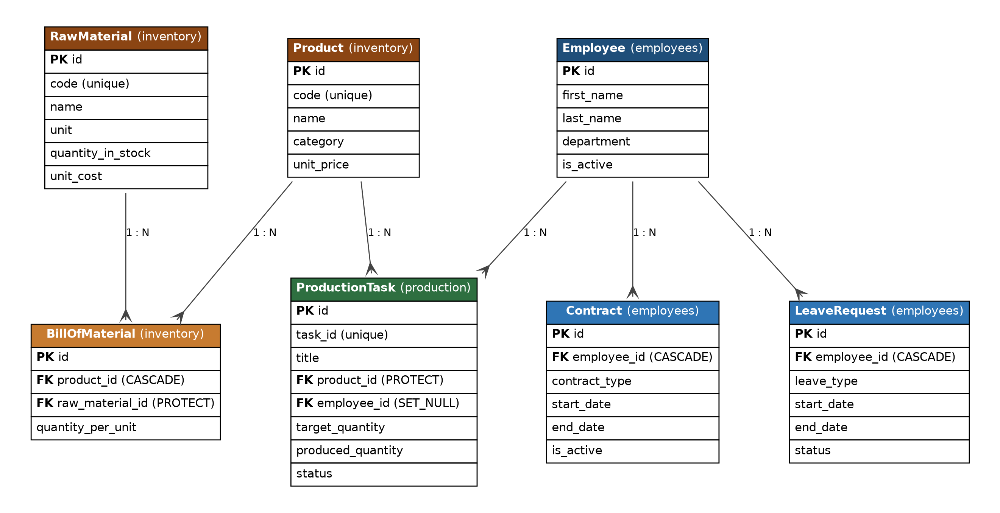
Figure 2: Entity Relationship Diagram (ERD) of the Production Management System

3.3 Cardinality Explanation
Table 4: Cardinality of the relationships
Relationship | Cardinality | Explanation and implementation
Product – RawMaterial | M : N | A leather bag requires multiple raw materials (leather, thread, zippers), and zippers are used across multiple products. This is resolved via the BillOfMaterial intermediate ("through") model, which strictly defines the quantity_per_unit required for the recipe.
Product – ProductionTask | 1 : N | One product can be manufactured in many production tasks; each task produces exactly one product.
Employee – ProductionTask | 1 : N | An artisan can be assigned multiple manufacturing tasks, but a specific task is assigned to only one artisan. Implemented with a ForeignKey (related_name='tasks').
Employee – Contract | 1 : N | An employee can have a history of multiple contracts. Implemented with a ForeignKey (CASCADE deletion).
Employee – LeaveRequest | 1 : N | An employee can have multiple leave requests. Implemented with a ForeignKey (CASCADE deletion).

4. URL Routing and Views
The project utilizes project-level URL patterns that map to app-level configurations (include ()).
Table 5: Main URL patterns and the views that handle them
URL pattern | View function | Purpose
/ | dashboard | Aggregates DB data to render the AdminLTE dashboard, workload radar and alerts.
/inventory/products/<int:pk>/ | product_detail | Dynamic-parameter view displaying product details, BOM, and calculated profit margins.
/inventory/products/add/ | product_create | Processes standard product creation alongside dynamic BOM inline formsets.
/employees/artisans/ | employee_list | Displays the HR roster, parsing @property methods to show live contract/leave statuses.
/production/tasks/<int:pk>/edit/ | task_update | Edits task progress; triggers dynamic raw material stock refunds/deductions upon save.
/production/tasks/<int:pk>/delete/ | task_delete | Confirmation step before deletion; triggers full stock refund to the warehouse.

4.1 Request Cycle Example
A request to GET /production/tasks/5/edit/ hits the main urls.py, routes to production.urls, and triggers task_update(request, pk=5). The view retrieves the object using get_object_or_404, populates the ModelForm, and renders task_form.html, which is returned to the browser as the HTTP response.
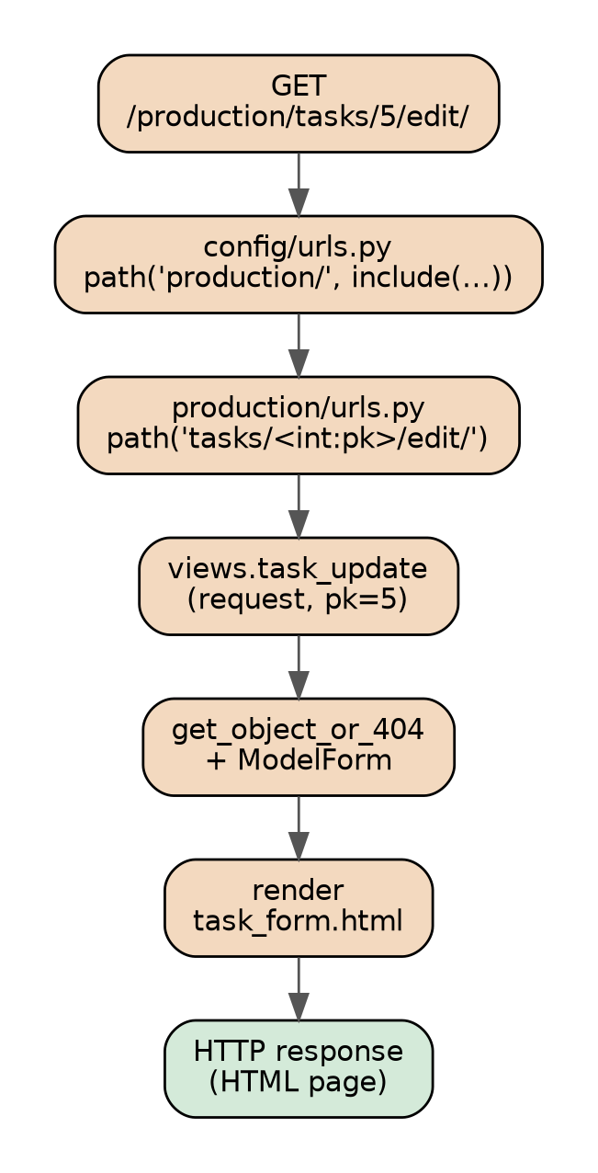
Figure 3: Request cycle: from the URL to the rendered response

5. Templates and AdminLTE Integration
The application successfully integrates the AdminLTE dashboard template using Django's template inheritance. AdminLTE is served from the static/ folder and loaded through Django's {% static %} tag inside the shared base template, so every page uses the same layout.
Table 6: Template components and AdminLTE integration
Component | Description
Base template (base.html) | Loads all static CSS, JavaScript, fonts, and plugins. Establishes a shared layout featuring a sidebar navigation menu and a top navigation bar populated with a "Quick Add" dropdown and dynamic user-role identification.
Dashboard (dashboard.html) | Extends base.html. Utilizes Bootstrap grid layouts (col-lg-8 and col-lg-4) to create summary cards, a recent tasks table populated with DB records, and a custom Active Workload UI.
DRY principle | Actions (View, Edit, Delete) are standardized across tables, and forms share a unified layout to maintain a consistent UI.
Dynamic data display | Records are displayed dynamically in tables (lists) and cards (detail pages), and the layout is responsive through the Bootstrap grid.

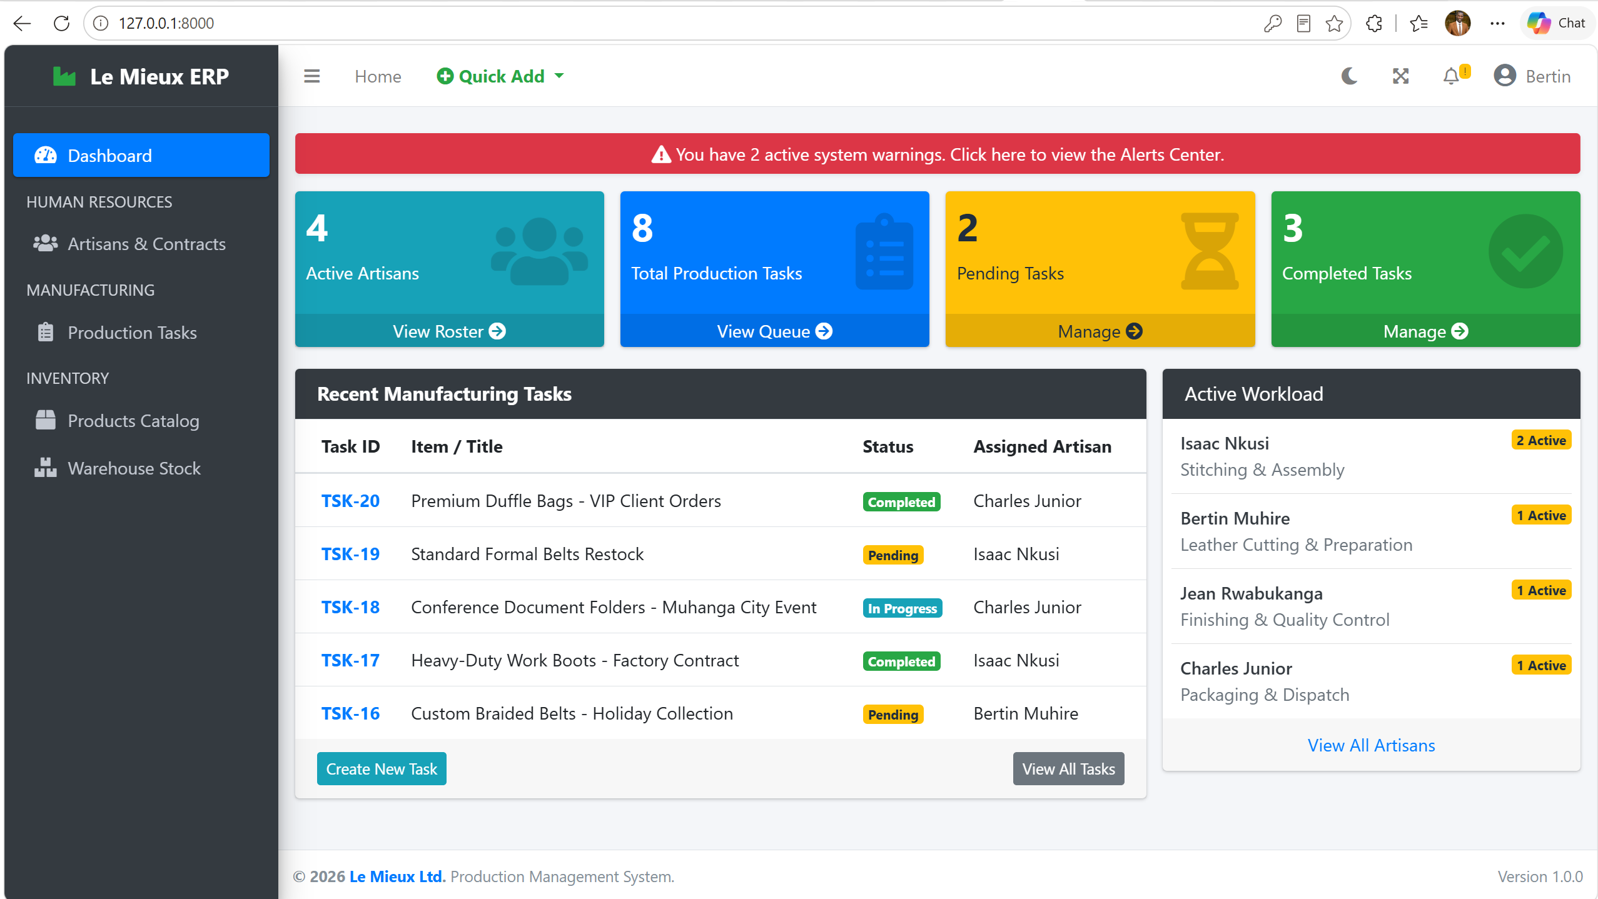
Figure 4: AdminLTE dashboard: summary cards, recent tasks table and Active Workload radar

6. CRUD Operations and Validation
The application supports robust Create, Read, Update, and Delete operations using Django Forms and ModelForms.

6.1 Core Operations
Table 7: CRUD operations implemented
Operation | Implementation
Create / Update | Uses unified HTML templates. ProductForm utilizes inlineformset_factory to allow users to build BOM recipes on the same page.
Read | List views (tables) and detail views (cards) dynamically display database records.
Delete | All deletions route to a confirm_delete.html page, explicitly fulfilling the requirement for a confirmation step before removing records.

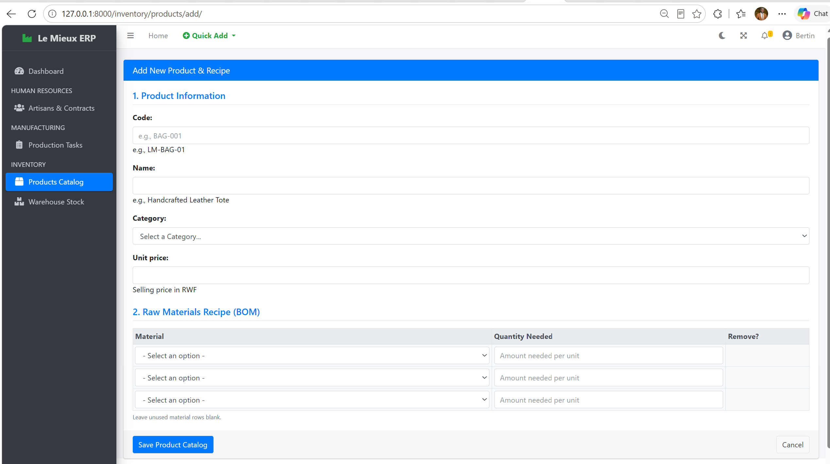
Figure 5: Product creation form with dynamic Bill of Materials (BOM) inline formset
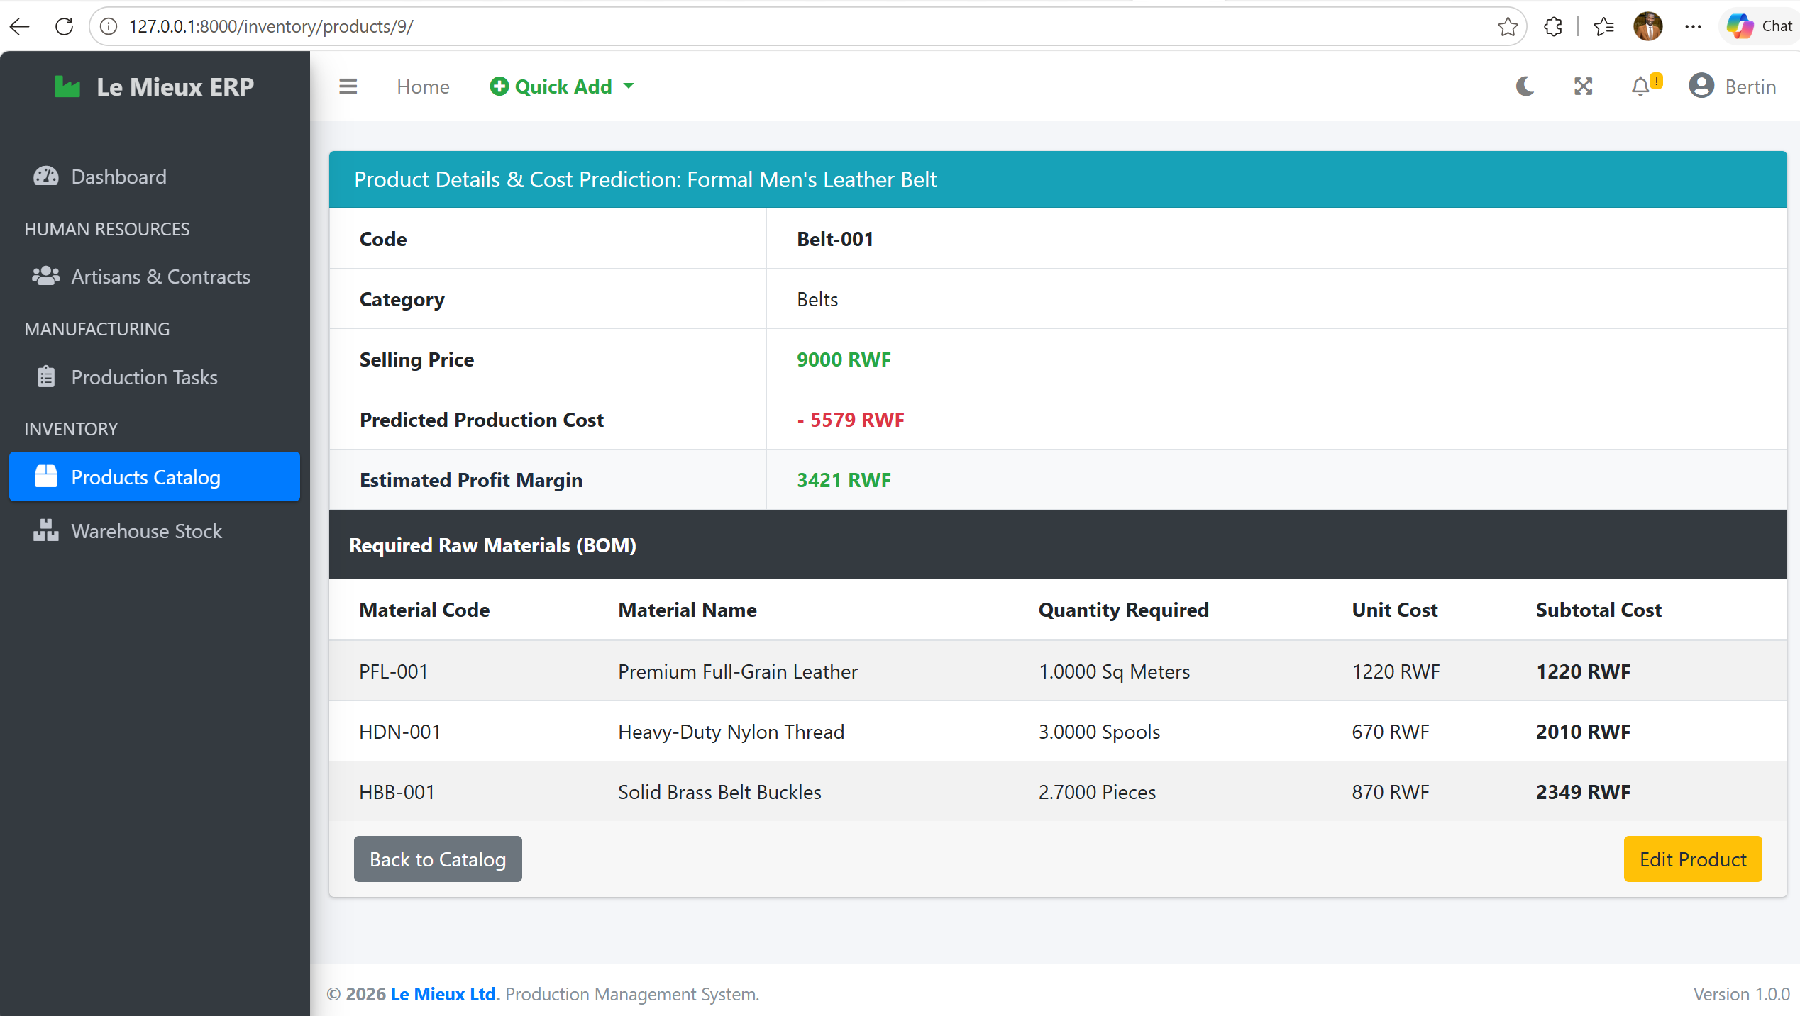
Figure 6: Product detail page showing the BOM, predicted cost and profit margin
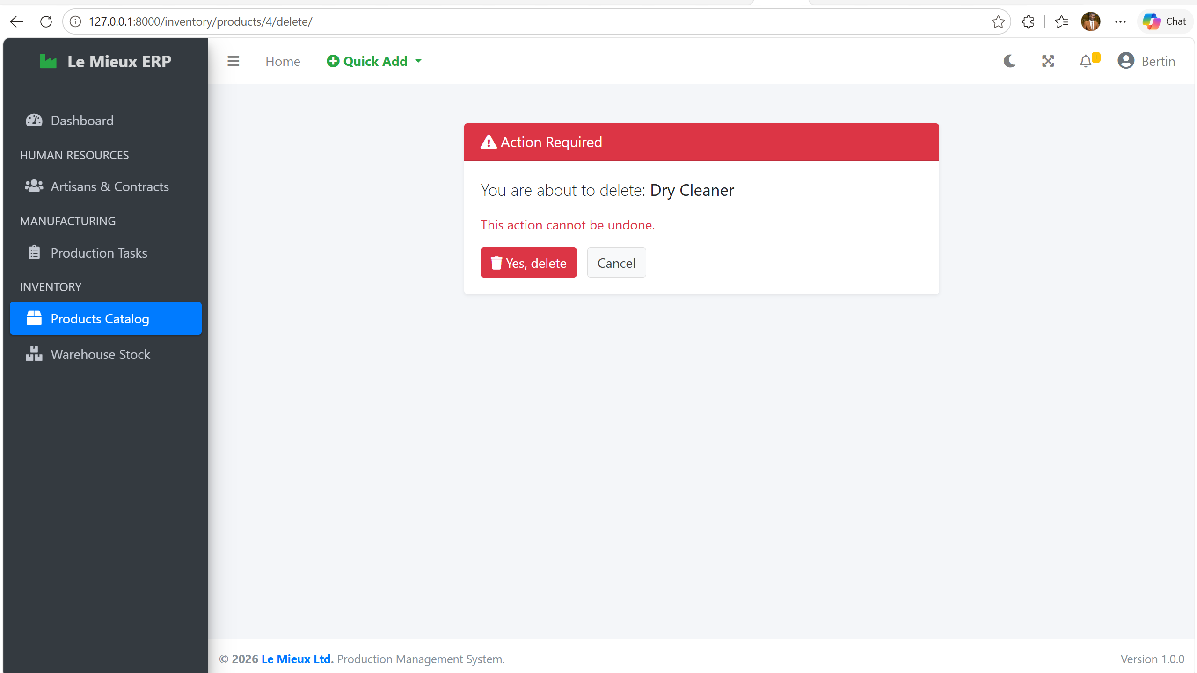
Figure 7: Delete confirmation page (confirm_delete.html)

6.2 Advanced Python Validations (`clean()` overrides)
Table 8: Validation rules
Rule | Description
State machine validation | A ProductionTask cannot be saved as "Pending" if progress is > 0. It cannot be "Completed" if progress does not equal the target amount.
Inventory protection rule | When a task is created, the form dynamically multiplies the requested quantity by the BOM recipe. If quantity_in_stock is insufficient, a ValidationError prevents creation.
Automated stock math | Overriding the save() and delete() methods allows the system to track the _original_target of a task. If a manager increases a task target, stock is deducted. If a task is deleted or the target is lowered, stock is mathematically refunded.

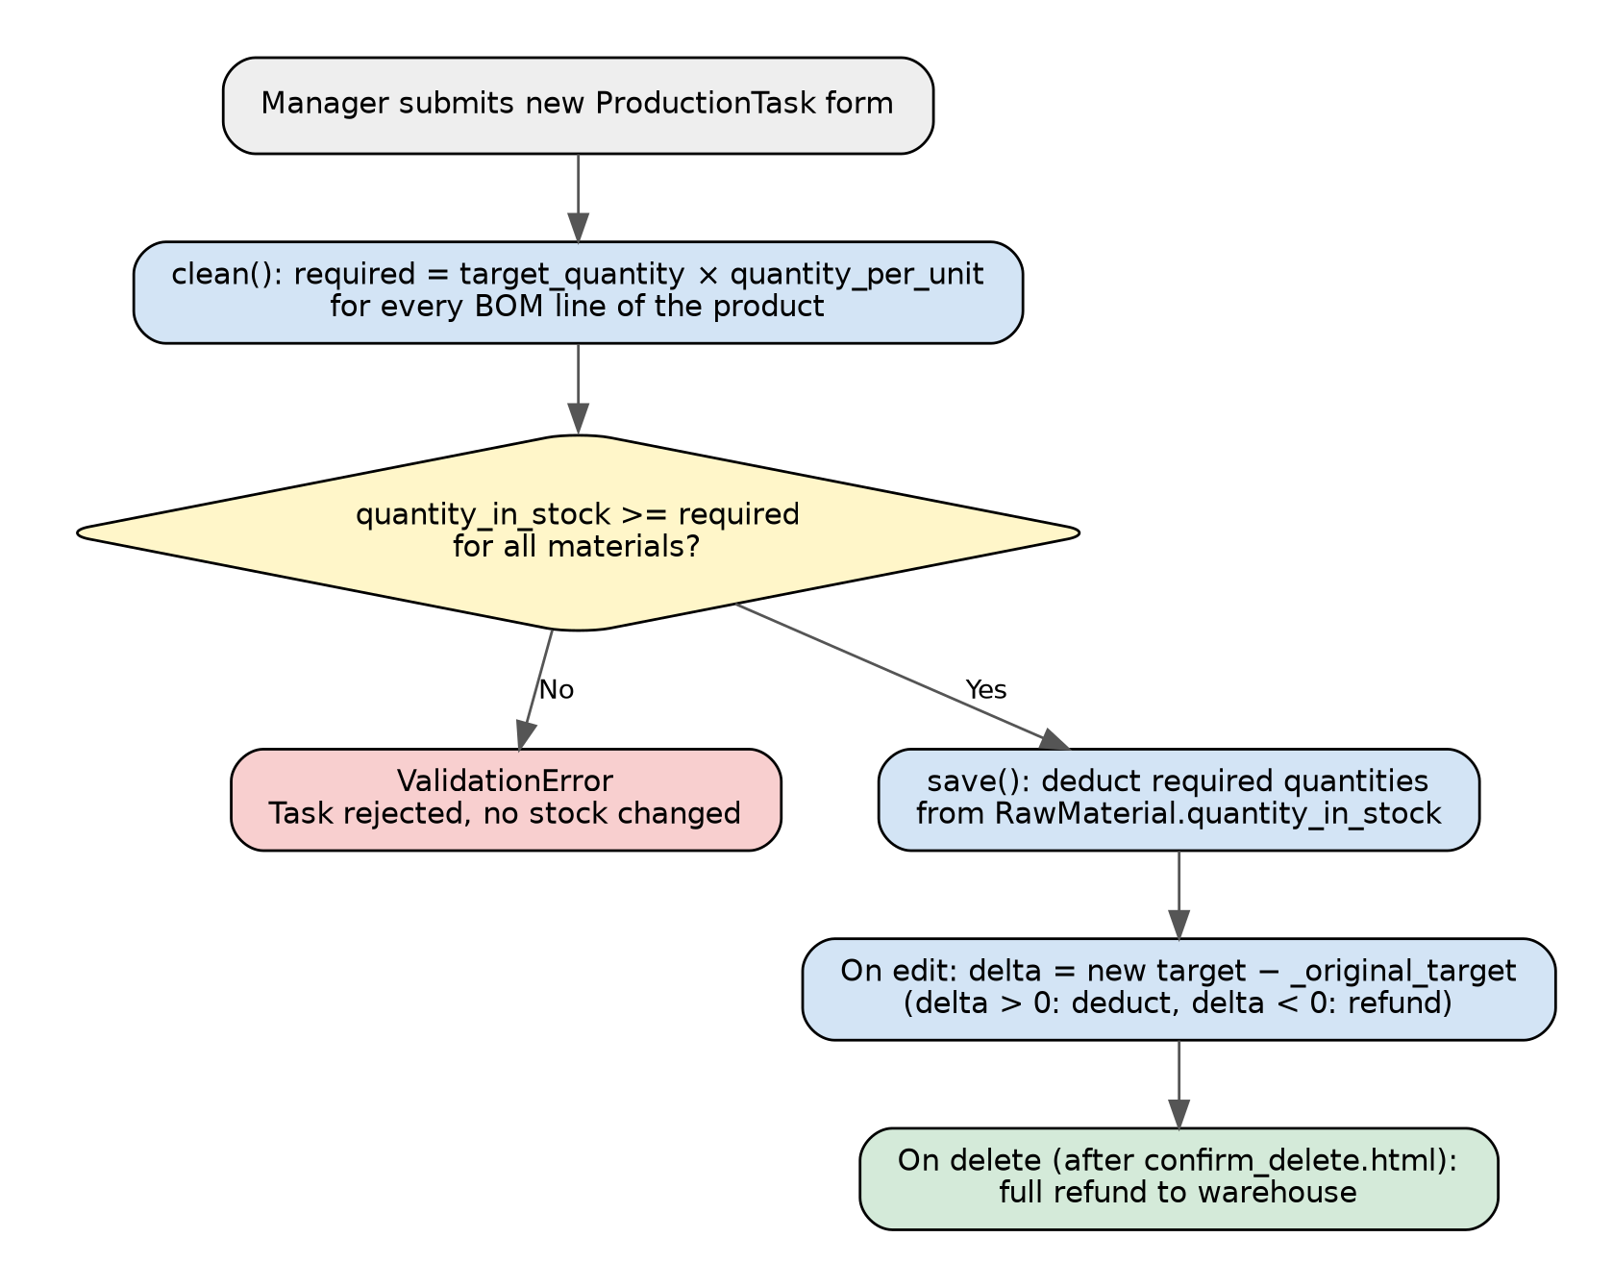
Figure 8: Inventory protection and automated stock deduction/refund logic
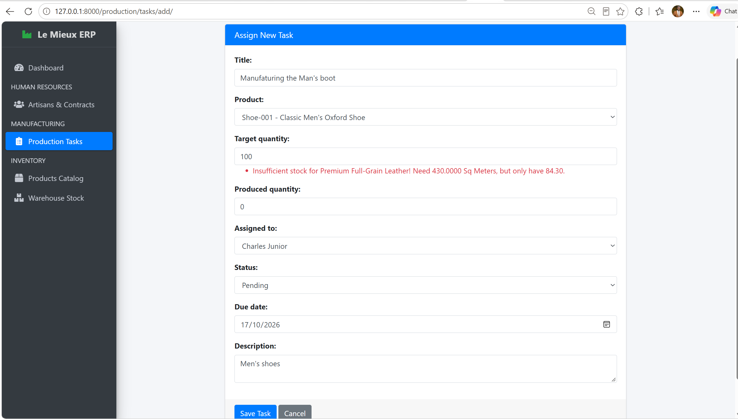
Figure 9: Validation error shown when the warehouse stock is insufficient for a new task

7. Django Admin and Authentication
Table 9: Django Admin and authentication features
Feature | Implementation
Django Admin | All models are registered in admin.py with custom list_display, search_fields, and list_filter configurations, allowing comprehensive management via the built-in Admin site (/admin/).
Superuser creation | A superuser account (admin) was created to oversee all factory operations.
Authentication | Django's built-in LoginView and LogoutView are implemented, with LOGIN_URL = 'login' in settings.py.
Authorization | Management pages (Create, Update, Delete) are strictly protected using the @login_required decorator and @user_passes_test wrappers, ensuring only HR/Production staff can modify records, while general artisans are restricted to view-only capabilities.

Table 10: Superuser account for demonstration
Item | Value
Admin URL | http://127.0.0.1:8000/admin/
Username | admin
Password | Admin@2026

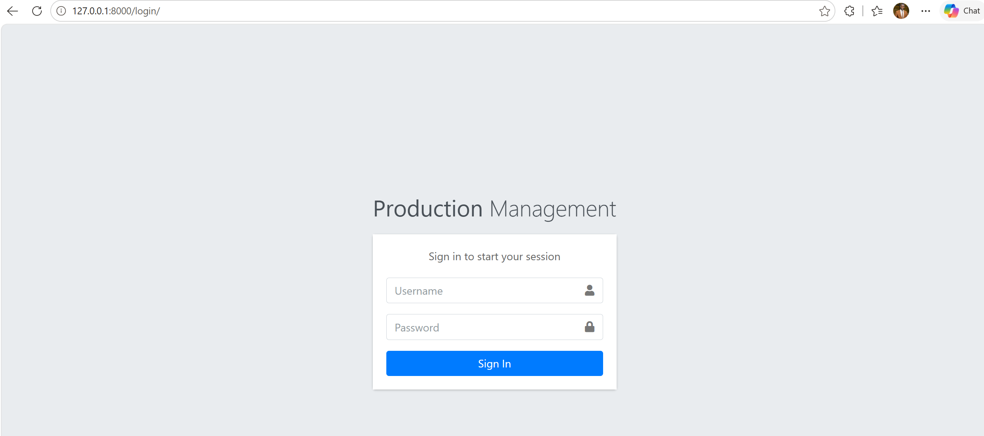
Figure 10: Login page of the application
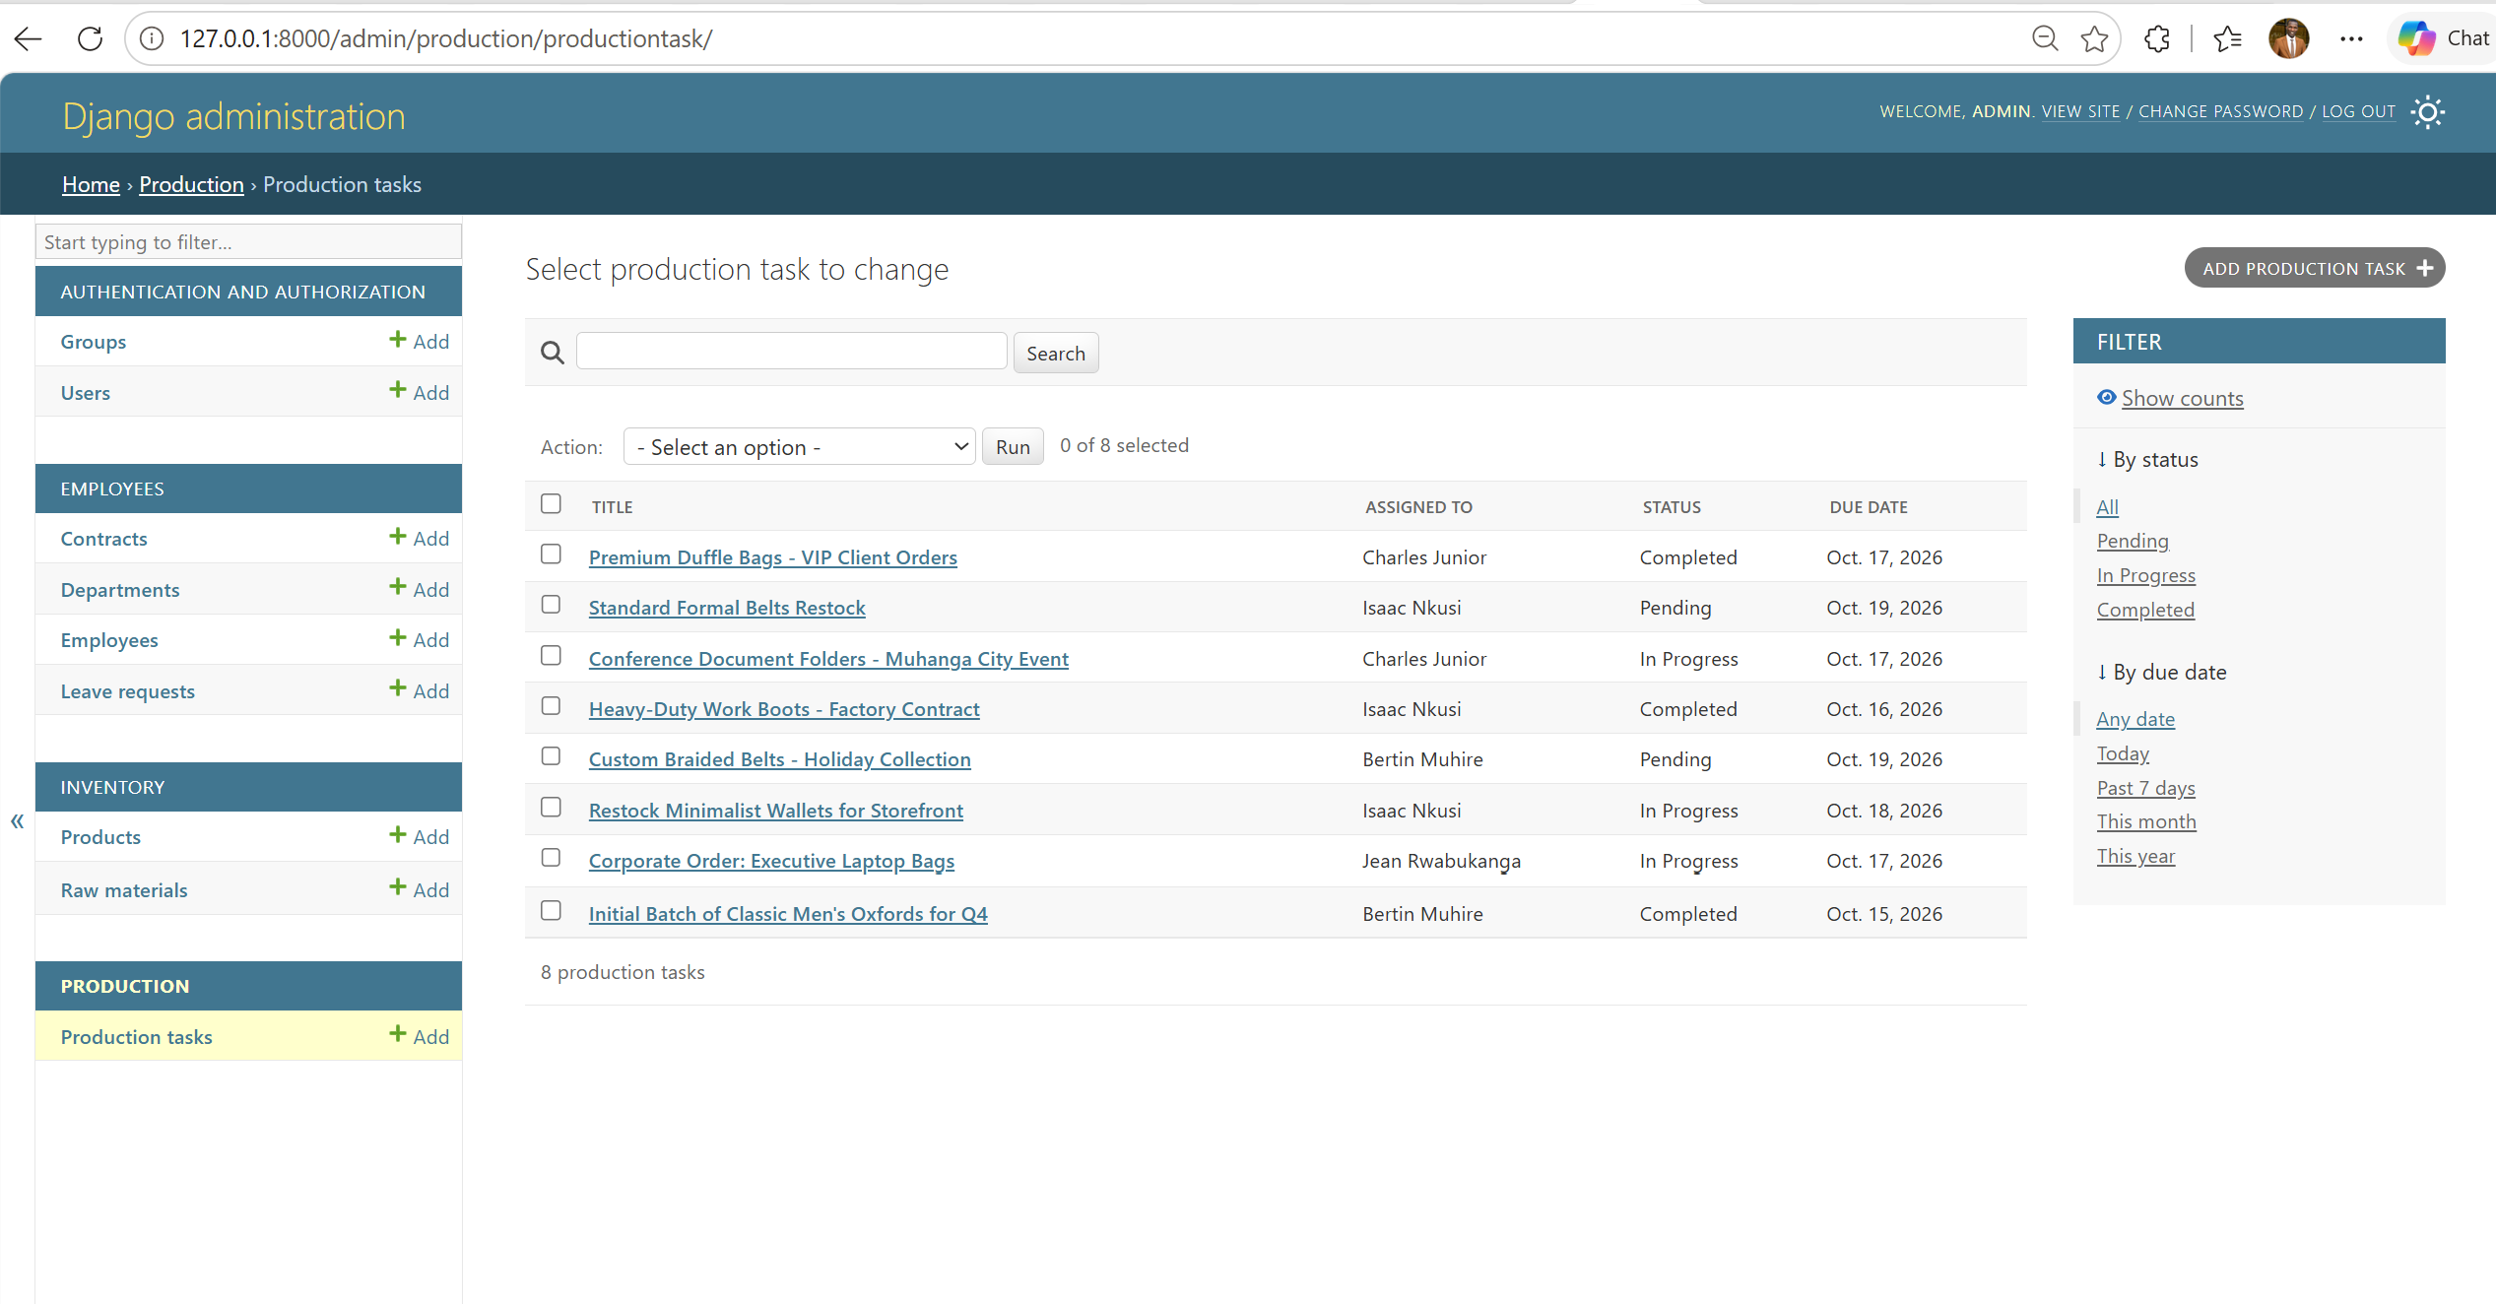
Figure 11: Django Admin site: registered models with list_display, search and filters
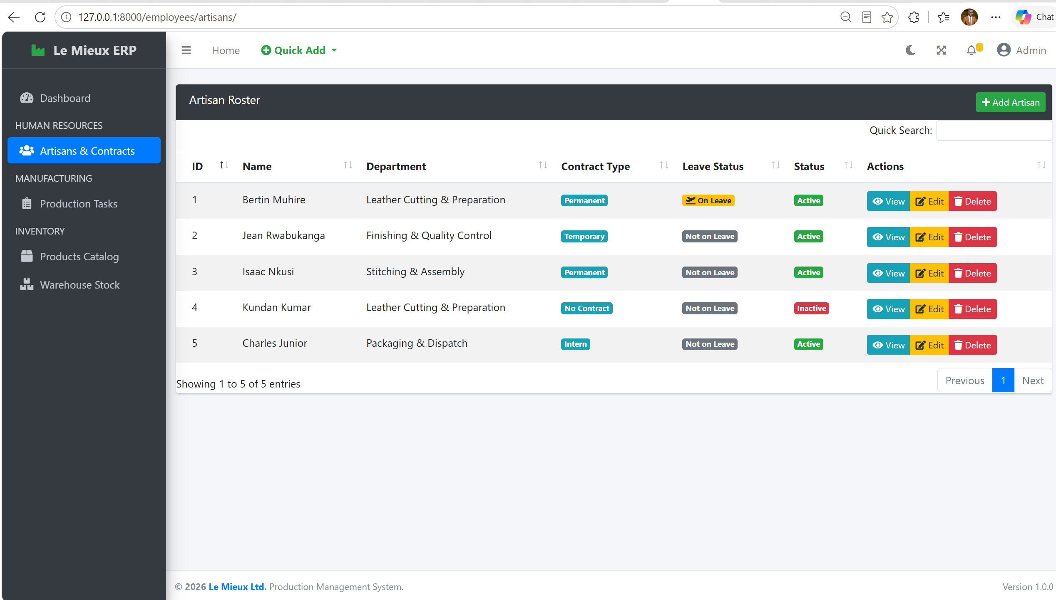
Figure 12: HR roster of artisans with live contract and leave statuses

8. Challenges and Solutions
Table 11: Main challenges faced and how they were solved
Challenge | Problem | Solution
Complex Recipe Creation (BOM) | Needed to assign raw materials while creating a product. | Solved using inlineformset_factory(Product, BillOfMaterial, form=BOMForm), allowing parent and child models to save simultaneously on one UI page.
Dashboard Query Optimization | Calculating active workloads dynamically without overwhelming the database. | Solved using Django's Count and Q objects: annotate(active_tasks=Count('tasks', filter=Q(tasks__status__in=['Pending', 'In Progress']))).
Accurate Stock Deductions | Ensuring edited tasks did not double-deduct stock. | Solved by overriding the model's __init__ method to track _original_target, allowing the save() method to calculate the exact delta to deduct or refund.
Form Validation Crashes | Validating leave requests crashed because the Employee FK wasn't attached. | Solved by defining form.instance.employee = employee before calling form.is_valid().

9. Conclusion
The Production Management System was successfully implemented. By meeting structural requirements (three apps, seven models), integrating the AdminLTE dashboard framework, and supporting dynamic BOM cost predictions and automated inventory deduction, the application delivers a comprehensive, highly functional solution to the real-world complexities of manufacturing.

Appendix A: How to Run the Project
- Extract the submitted ZIP file.
- Open the terminal in the root directory and create and activate the virtual environment: python -m venv venv followed by venv\Scripts\activate (Windows).
- Install dependencies: pip install -r requirements.txt.
- Run migrations to build the SQLite database: python manage.py makemigrations and python manage.py migrate.
- Start the server: python manage.py runserver.
- Access the dashboard at http://127.0.0.1:8000/.
- The Django Admin panel is accessible via /admin/.

